

Practices for Secure Software Report

Table of Contents
Document Revision History 3
Client 3
Instructions 3
Developer 4
1. Algorithm Cipher 4
2. Certificate Generation 4
3. Deploy Cipher 5
4. Secure Communications 5
5. Secondary Testing 5
6. Functional Testing 6
7. Summary 7
8. Industry Standard Best Practices 8

Document Revision History

Version | Date | Author | Comments
1.0 | 06/21/2026 | Jeremiah (Jay) Case

Client



Instructions

Submit this completed practices for secure software report. Replace the bracketed text with the relevant information. You must document your process for writing secure communications and refactoring code that complies with software security testing protocols.

- Respond to the steps outlined below and include your findings.
- Respond using your own words. You may also choose to include images or supporting materials. If you include them, make certain to insert them in all the relevant locations in the document.
- Refer to the Project Two Guidelines and Rubric for more detailed instructions about each section of the template.

Developer
Jeremiah (Jay) Case

Algorithm Cipher

SHA-256 is an appropriate cryptographic hash algorithm for Artemis Financial because the company needs a secure way to verify data integrity when information is transferred through its web application. SHA-256 is part of the Secure Hash Algorithm 2 family and produces a fixed 256-bit hash value from the input data. This makes it useful for checksum verification because even a small change in the original data will create a very different hash output.

For this project, SHA-256 helps confirm that the data has not been changed or corrupted during transfer. A hash function is not the same as encryption because it is one-way, meaning the original data cannot realistically be recreated from the hash value. This is helpful for Artemis Financial because the company handles sensitive financial information and needs to protect the accuracy and integrity of customer data.

Encryption also supports secure communication through HTTPS/TLS. TLS commonly uses asymmetric encryption during the handshake process and symmetric encryption after a secure session is established. Asymmetric encryption uses a public and private key pair, which helps with authentication and secure key exchange. Symmetric encryption uses one shared session key and is faster for protecting the actual communication after the connection is established. Random numbers are also important because they help create secure session keys and reduce predictability.

Encryption has developed from simple historical ciphers into modern algorithms designed to protect digital systems, financial data, and online communication. Today, algorithms such as SHA-256, RSA, AES, and TLS are widely used because they provide stronger protection against modern cyber threats. For Artemis Financial, using SHA-256 for checksum verification and HTTPS for secure communication adds important layers of protection and support secure coding best practices.

Certificate Generation
Insert a screenshot below of the CER file.

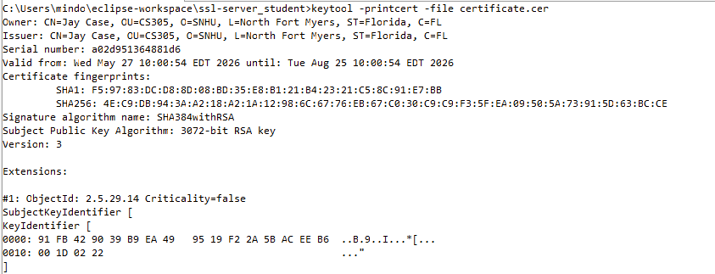

Deploy Cipher
Insert a screenshot below of the checksum verification.

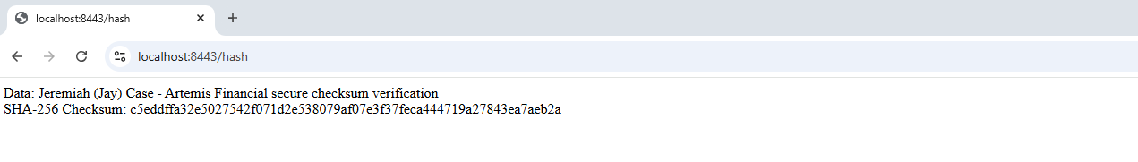

Secure Communications
Insert a screenshot below of the web browser that shows a secure webpage.

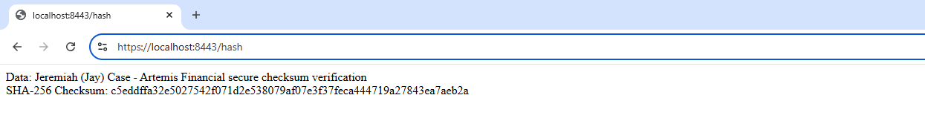

Secondary Testing
Insert screenshots below of the refactored code executed without errors and the dependency-check report.

A secondary static analysis was performed using OWASP Dependency-Check after the application was refactored. The results were reviewed to verify that the SHA-256 checksum implementation, SSL certificate configuration, and HTTPS communications settings did not introduce additional security vulnerabilities. A suppression.xml file was created and configured through the Maven dependency-check plugin to suppress a reviewed low-confidence identifier associated with json-smart-v2. After rerunning the dependency-check scan, the report confirmed that one finding was successfully suppressed and that no new vulnerabilities were introduced by the refactored code. The remaining vulnerabilities were associated with existing third-party framework dependencies rather than the security enhancements implemented during this project.

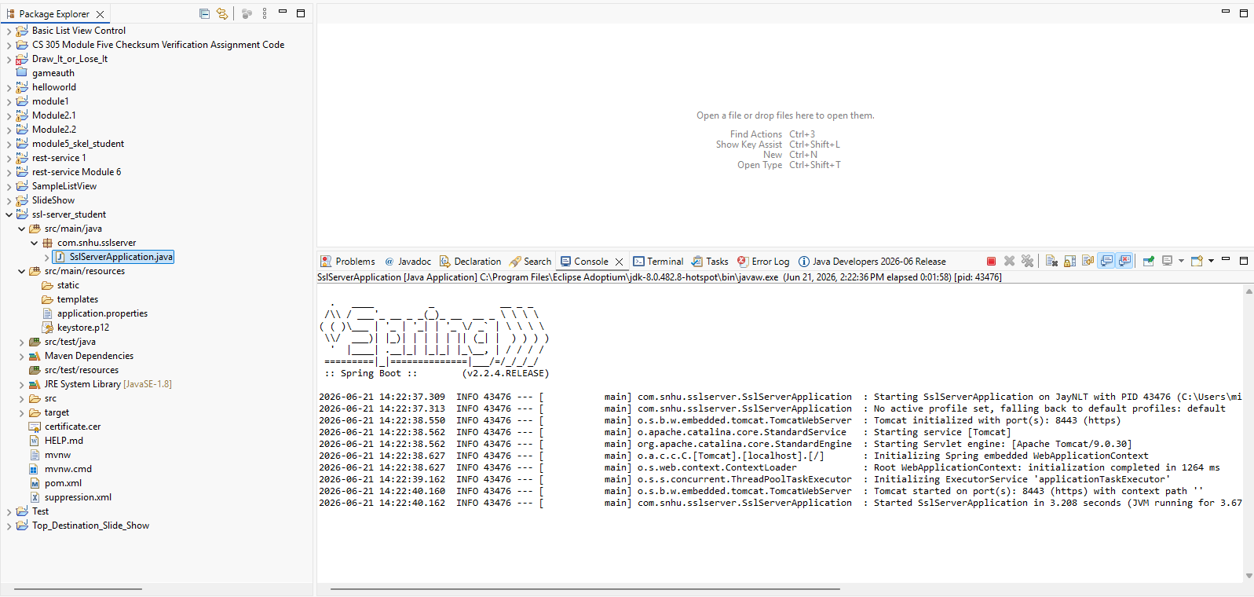

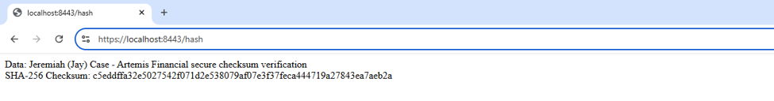
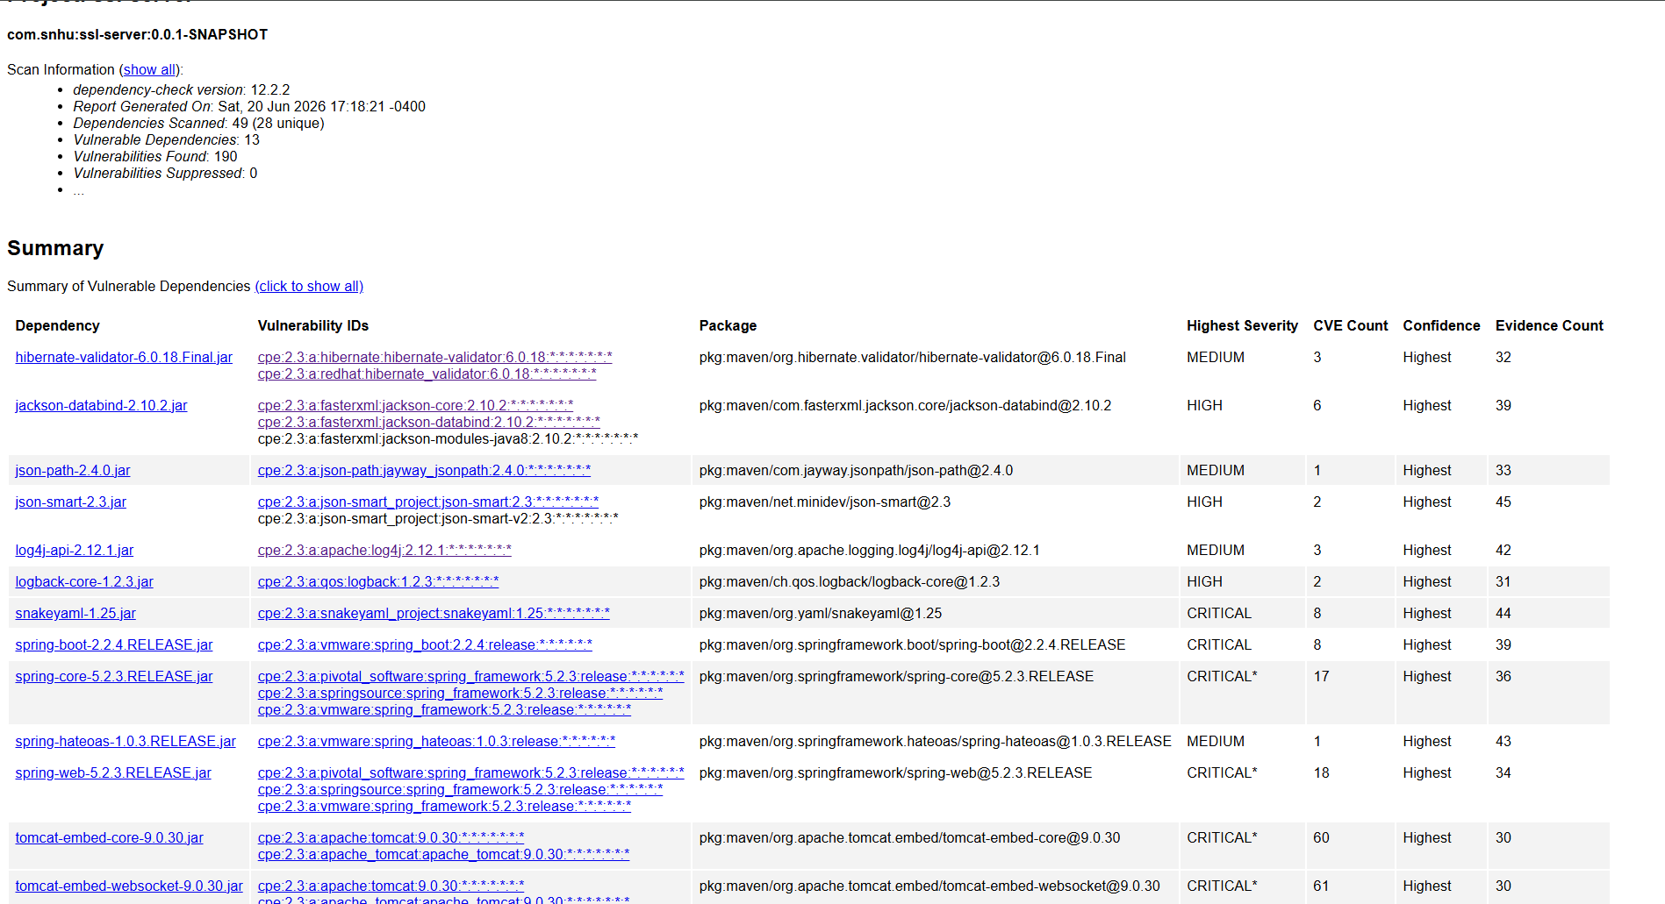

Functional Testing
Insert a screenshot below of the refactored code executed without errors.

A manual review of the refactored code was performed to identify potential syntactical, logical, and security vulnerabilities. During the review, the application code was examined to verify proper implementation of the SHA-256 checksum functionality, secure HTTPS communication settings, and SSL certificate configuration. No syntax errors or logical errors were identified during testing. Security review confirmed that SHA-256 was used instead of weaker hashing algorithms and that HTTPS was properly configured to protect data transmitted between the client and server. Functional testing verified that the application executed successfully and generated the expected checksum output without errors.

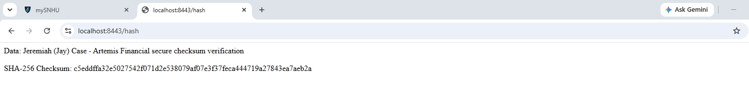

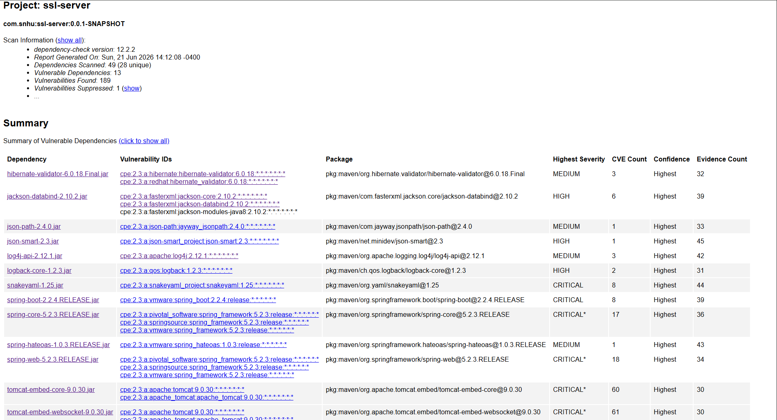

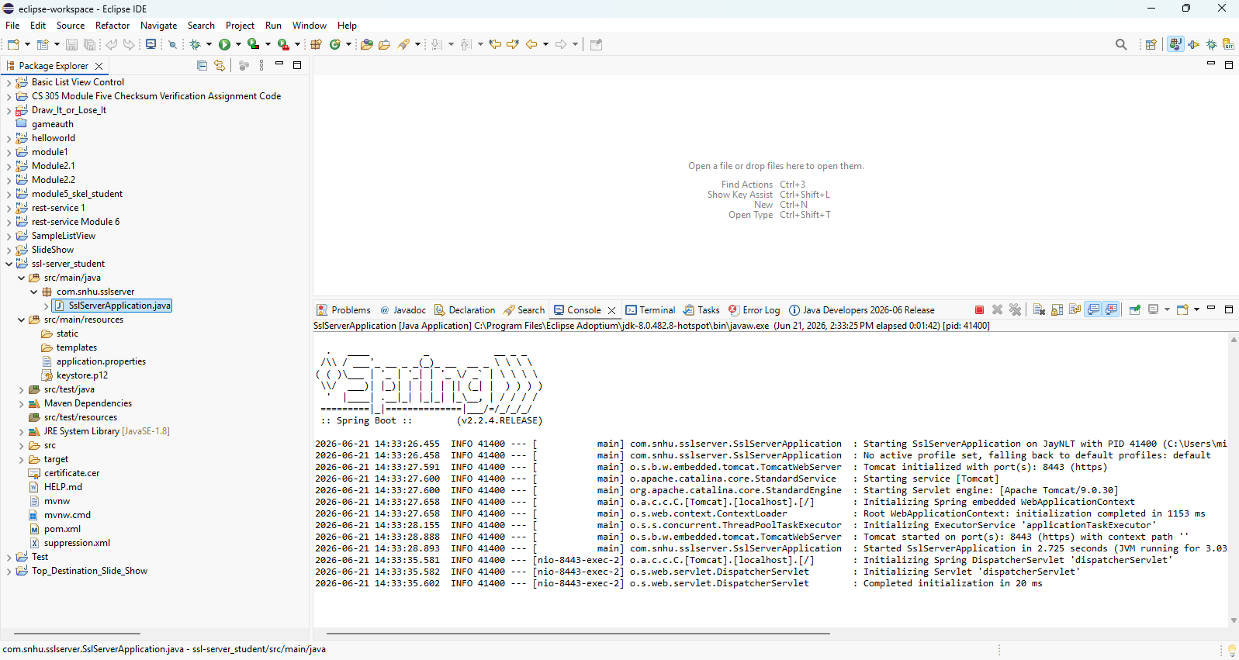

Summary

The Artemis Financial application was refactored to improve secure communication, data integrity, and cryptographic security. Refactoring included configuring HTTPS with SSL/TLS, generating and using a self-signed certificate, and adding SHA-256 checksum verification through the /hash endpoint.

Following the vulnerability process, I addressed the areas of secure communications, cryptography, and dependency vulnerability testing. HTTPS added protection for data in transit, while SHA-256 checksum verification added a layer of data integrity protection. The application was then functionally tested to verify that the refactored code executed without errors.

I also completed secondary static testing using OWASP Dependency-Check. When errors or potential vulnerabilities appeared, I reviewed the output, adjusted configuration, checked the dependencies, and reran the scan until a successful dependency-check report was generated. The final report showed that the refactored code did not introduce new vulnerabilities through the SHA-256 checksum feature or HTTPS configuration. A suppression.xml file was also implemented and validated through a second dependency-check scan, resulting in one reviewed low-confidence finding being suppressed while preserving all legitimate vulnerability findings.

Overall, the refactoring process added multiple layers of security and followed secure software testing protocols by combining manual review, functional testing, HTTPS verification, checksum verification, and static dependency analysis.

Industry Standard Best Practices

Industry standard best practices for secure coding were applied by using strong encryption practices, secure communication, dependency scanning, and functional testing. The application was refactored to use HTTPS with SSL/TLS so data transmitted between the client and server would be encrypted. SHA-256 was also used for checksum verification because it is a stronger hashing algorithm than outdated options such as MD5 or SHA-1.

To maintain the application’s existing security, I avoided adding unnecessary external libraries and used Java’s built-in MessageDigest class for hashing. I also ran OWASP Dependency-Check to review third-party dependencies for known vulnerabilities and verify that the refactored code did not introduce additional security risks.

Industry best practices also include regularly reviewing third-party dependencies and managing false positives through documented suppression rules. To support this process, a suppression.xml was configured within the Maven dependency-check plugin. This allowed reviewed low-confidence findings to be suppressed while ensuring that legitimate vulnerabilities remained visible for analysis and remediation.

Applying secure coding best practices is valuable to Artemis Financial because the company handles sensitive financial data. Secure coding helps protect customer information, reduce the risk of data breaches, maintain customer trust, support regulatory compliance, and protect the company’s reputation and long-term business stability.

